*** UNCLASSIFIED ***

SAR Probability of Containment Map
START TIME POSITION RADIUS FOR SAR DRIFT CALCULATIONS
041700Z SEP2002 02-30.0N 079-30.0W 015NM

LEEWAY CODE : 0 (MAN IN WATER)

SEARCH TIME POSITION RADIUS OF SEARCH (CONTAINMENT)
50 PCT 75 PCT 90 PCT
041700Z SEP2002 02-29.8N 079-30.0W 0009NM 0012NM 0016NM
042300Z SEP2002 02-29.7N 079-27.8W 0009NM 0012NM 0016NM
050500Z SEP2002 02-29.2N 079-25.5W 0009NM 0013NM 0016NM
051100Z SEP2002 02-28.9N 079-24.2W 0009NM 0013NM 0016NM
051700Z SEP2002 02-29.0N 079-23.1W 0009NM 0013NM 0016NM
052300Z SEP2002 02-28.8N 079-21.5W 0009NM 0013NM 0017NM

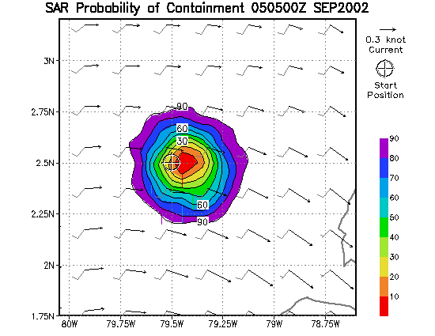
CONDITIONS AT MAP CENTER 02-28.5N 079-19.5W VALID ON 050600Z SEP2002
WIND SPEED 008 KNOTS (COAMPS_CENT_AM)
WIND DIRECTION (FROM) 214 DEGREES (COAMPS_CENT_AM)
WAVE HEIGHT 2.2 FEET (WW3_CENT_AM)
PRIMARY PERIOD 11 SEC (WW3_CENT_AM)
PRIMARY DIRECTION 229 DEGREES (WW3_CENT_AM)
SECONDARY PERIOD 05 SEC (WW3_CENT_AM)
SECONDARY DIRECTION 022 DEGREES (WW3_CENT_AM)
WHITE CAPS 000 PROB (WW3_CENT_AM)
CLOUD COVER 8 TENTHS (NOGAPS)
AIR TEMPERATURE 25 C ( 076 F) (COAMPS_CENT_AM)
SEA TEMPERATURE 26 C ( 079 F) (TOPS_GLOBAL)
CURRENT SPEED 0.1 KNOTS (TOPS_GLOBAL)
CURRENT DIRECTION (TO) 077 DEGREES (TOPS_GLOBAL)
END TWILIGHT (NAUT.) 0006 ZULU 0.0093 LUX
BEGIN TWILIGHT (NAUT.) 1027 ZULU 0.0098 LUX
SUNRISE 1112 ZULU 468.2716 LUX
SUN TRANSIT 1716 ZULU 121990.2422 LUX 85.4N
SUNSET 2321 ZULU 434.7992 LUX
MOONRISE 0848 ZULU 0.0005 LUX 11%
MOON TRANSIT 1507 ZULU 97989.4297 LUX 09% 69.8N
MOONSET 2125 ZULU 42719.5234 LUX 07%
WIND CHILL FACTOR 025 C ( 076 F)
SURVIVAL TIME WITH SUIT 26 HOURS
SURVIVAL TIME WITHOUT SUIT 14 HOURS

